S.No | Category | S.No | Topic
1 | Networking Fundamentals | 1 | OSI Model
 |  | 2 | TCP Header
 |  | 3 | IP Header
 |  | 4 | TCP Three-Way Handshake
 |  | 5 | TCP Options
 |  | 6 | TCP Flags
 |  | 7 | TCP Timers
2 | Network Protocols & Services | 8 | ARP (Types of ARP)
 |  | 9 | DHCP
 |  | 10 | DNS
 |  | 11 | DNS over HTTP (DoH)
3 | Network Diagnostic Tools | 12 | Ping: How it works
 |  | 13 | Traceroute: How it works
 |  | 14 | Telnet
4 | HTTP / Web Protocols | 15 | HTTP vs HTTPS
 |  | 16 | HTTP Request Methods
 |  | 17 | HTTP Response Codes
 |  | 18 | Browser Header Traces
5 | TLS / SSL Security | 19 | TLS Handshake
 |  | 20 | SSL Handshake (Certificate validation, Intermediate CA, Root CA)
 |  | 21 | How client verifies the server certificate
 |  | 22 | SNI (Server Name Indication)
 |  | 23 | Subject Alternative Name (SAN)
 |  | 24 | TLS 1.2 Handshake (Detailed)
 |  | 25 | TLS 1.3 Handshake (Detailed)
6 | VPN & Tunneling Technologies | 26 | GRE (Generic Routing Encapsulation)
 |  | 27 | IPsec
 |  | 28 | GRE vs IPsec
 |  | 29 | NAT Traversal (NAT-T)
 |  | 30 | IPsec IKEv1 Main Mode (6 packets with payloads)
 |  | 31 | IPsec IKEv1 Aggressive Mode (4 packets with payloads)
 |  | 32 | IPsec Quick Mode (with payloads)
7 | Identity & Authentication | 33 | SAML (IdP Initiated Flow)
 |  | 34 | SAML (SP Initiated Flow)
 |  | 35 | Authentication using SAML: How it works
 |  | 36 | SCIM
8 | Zero Trust & Zscaler | 37 | Zero Trust Architecture
 |  | 38 | Overview of Zscaler Products (ZIA, ZPA)
9 | Network Security & Infrastructure | 39 | Difference between Proxy and Firewall
10 | Network Troubleshooting | 40 | Troubleshooting latency issues using Wireshark

Networking Fundamentals
- What is OSI Model?
The OSI (Open Systems Interconnection) Model is a 7-layer conceptual framework developed by the International Organization for Standardization (ISO). It explains how data travels from one computer to another over a network and how different computer systems communicate with each other. Each layer has specific functions and responsibilities, which helps standardize communication and allows different devices and technologies to work together
Layers of OSI Model
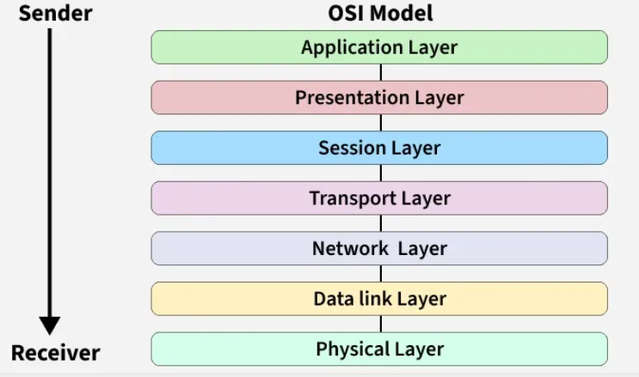

S.No | Layer | Working | Protocol Data Unit | Protocols
1 | Physical Layer | Establishing Physical Connections between Devices. | Bits | USB, SONET/SDH, etc.
2 | DataLink Layer | Node to Node Delivery of Message. | Frames | Ethernet, PPP, etc.
3 | Network Layer | Transmission of data from one host to another,  located in different networks. | Packets | IP, ICMP, IGMP, OSPF, etc.
4 | Transport Layer | Take Service from Network Layer and provide it to  the Application Layer. | Segments (for TCP) or Datagrams (for UDP) | TCP, UDP, SCTP, etc.
5 | Session Layer | Establishes Connection, Maintenance, Ensures  Authentication and Ensures security. | Data | NetBIOS, RPC, PPTP, etc.
6 | Presentation Layer | Data from the application layer is extracted and  manipulated in the required format for transmission. | Data | TLS/SSL, MIME, etc.
7 | Application Layer | Helps in identifying the client and synchronizing communication. | Data | FTP, SMTP, DNS, DHCP, etc.

- Transmission Control Protocol (TCP) header
TCP (Transmission Control Protocol) is a reliable transport protocol as it establishes a connection before sending any data and everything that it sends is acknowledged by the receiver

When computers send data over the internet, they don’t send it as one big file. They break it into small pieces called TCP segments. Each segment has two parts:
- Header → Control information (like instructions)
- Data → The actual message
👉 TCP Header = A small block of information attached before the data so the receiver knows how to handle it.

Real Life Example:
Imagine you send 5 pages of a document by courier in 5 separate envelopes. On each envelope you write
- From address
- To address
- Page number (1/5, 2/5…)
- Special instructions
That label = TCP Header
The papers inside = Actual Data
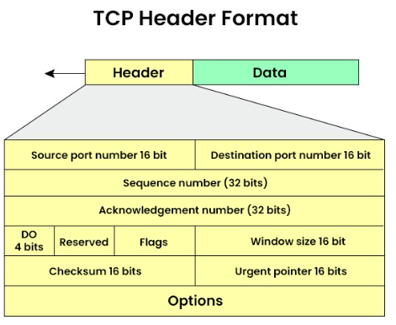

TCP HEADER STRUCTURE (20–60 Bytes)
Field | Size | Purpose | Related TCP Feature
Source Port | 16 bits | Sender application port | Process-to-process delivery
Destination Port | 16 bits | Receiver application port | Process-to-process delivery
Sequence Number | 32 bits | Order of bytes sent | Reliable & Ordered delivery
Acknowledgment Number | 32 bits | Next expected byte | Reliability (ACK)
Header Length | 4 bits | Size of TCP header | Proper data parsing
Reserved | 6 bits | Future use | —
Flags (URG, ACK, PSH, RST, SYN, FIN) | 6 bits | Control connection | Connection setup & termination
Window Size | 16 bits | How much data receiver can accept | Flow Control
Checksum | 16 bits | Error checking | Error Control
Urgent Pointer | 16 bits | Urgent data position | Special data handling
Options (Optional) | 0–40 bytes | Extra features (MSS, scaling) | Performance & Congestion control

- IP header or IPv4 packet header
IPv4 stands for Internet Protocol version 4 is the addressing system which assigns unique labels to devices on the internet. You can think of IPv4 as the address label on a package you are sending in the mail. Just like the label includes information about the sender, receiver, and nature of the contents, the IPv4 Header also contains information regarding the data that is being sent over the internet.

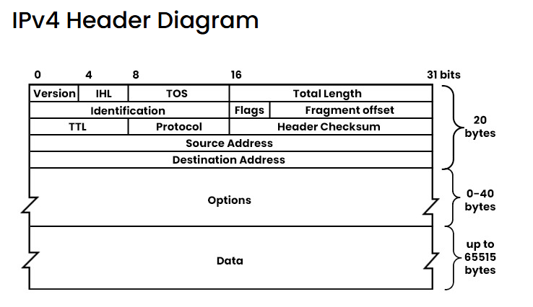
Field | Size | Purpose (Easy Meaning)
Version | 4 bits | Tells IP version. For IPv4, value is 4.
IHL (Internet Header Length) | 4 bits | Header length. Minimum is 20 bytes, can be more if options are used.
TOS (Type of Service) / DSCP | 8 bits | Tells network how to treat the packet (priority, delay, reliability). Used for QoS.
Total Length | 16 bits | Full packet size = Header + Data. Max = 65,535 bytes.
Identification | 16 bits | Used to identify fragments of the same original packet. Important during fragmentation.
Flags | 3 bits | Controls fragmentation.  • 1 bit unused  • DF = Don’t Fragment  • MF = More Fragments coming
Fragment Offset | 13 bits | Tells where this fragment belongs in the original packet.
TTL (Time to Live) | 8 bits | Limits how long packet can travel. Reduced by 1 at each router. If it reaches 0, packet is dropped. Prevents infinite looping.
Protocol | 8 bits | Tells which protocol is inside the data part.  Examples: 6 = TCP, 17 = UDP, 1 = ICMP
Header Checksum | 16 bits | Error-checking for the header only (not data). Recalculated at every router.
Source Address | 32 bits | Sender’s IPv4 address.
Destination Address | 32 bits | Receiver’s IPv4 address.
Options (Optional) | 0–40 bytes | Extra features like security, timestamp, routing. Rarely used today. Makes header longer than 20 bytes.
Data (Payload) | Variable | Actual data being carried (like TCP segment, UDP data, etc.).

- TCP 3: way handshake

4.1 Transmission Control Protocol (TCP)
Transmission Control Protocol (TCP) is a transport layer protocol used to send data reliably between two devices over a network.

Key features
- Reliable communication
- Ensures data is delivered in order
- Error checking and retransmission if packets are lost
- Connection-oriented (connection must be established before data transfer)

Example: When you open a website using Hypertext Transfer Protocol (HTTP), TCP is used underneath to send the data.
TCP 3 - Way Handshake is the process TCP uses to establish a connection between a client and a server before data transfer starts.

4.2 TCP 3: way handshake
The TCP Three-Way Handshake is the process TCP uses to establish a connection between a client and a server before data transfer starts.

Steps in the TCP 3-Way Handshake
- SYN (Synchronize)
- The client sends a TCP packet with the SYN flag set.
- It includes an Initial Sequence Number (ISN).
- Purpose: "I want to start a connection. Here's my sequence number."
- SYN-ACK (Synchronize-Acknowledge)
- The server responds with a packet that has both SYN and ACK flags set.
- It acknowledges the client’s ISN and sends its own ISN.
- Purpose: "Got your request. Here's my sequence number too."
- ACK (Acknowledge)
- The client sends a final packet with the ACK flag set.
- It acknowledges the server’s ISN.
- Purpose: "Acknowledged. Let’s start communicating."

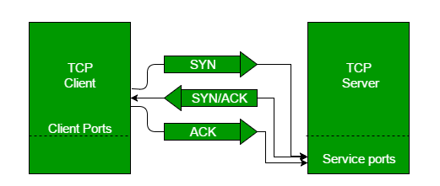

Why It Matters
- Ensures reliable communication by synchronizing sequence numbers.
- Prevents data loss and connection errors.
- Forms the basis for secure and ordered data transfer in TCP/IP networks

- TCP Options
TCP Options are extra parameters in the TCP header used to improve TCP performance and functionality.

Common TCP Options:
- MSS (Maximum Segment Size): Maximum data size in one TCP segment
- Window Scaling: Increases TCP window size for high-speed networks
- SACK (Selective Acknowledgment): Allows receiver to acknowledge specific packets
- Timestamp: Helps calculate round-trip time

Simple: TCP options provide additional features to optimize TCP communication.

- TCP Flags
TCP Flags are control bits in the TCP header used to control connection state and data flow.

Common TCP Flags:
- Synchronize (SYN): Start connection
- Acknowledgment (ACK): Acknowledge received data
- Finish (FIN): Close the connection
- Reset (RST): Reset/terminate the connection immediately
- Push (PSH): Send data immediately to the application
- Urgent (URG): Indicates urgent data in the packet

Short interview line:
TCP flags are control bits used to establish, manage, and terminate TCP connections.

- TCP Timers
TCP Timers control time-based events in TCP communication.

Common TCP Timers
- Retransmission Timer: Resends lost packets
- Persistence Timer: Prevents deadlock when window size is zero
- Keepalive Timer: Checks if connection is still active
- Time-Wait Timer: Ensures delayed packets are handled before closing connection

Simple: TCP timers manage retransmissions and connection reliability using time control.

- ARP
ARP stands for Address Resolution Protocol, it is used to find the MAC address of a device when we already know its IP address.

What is a MAC Address?
MAC address stands for Media Access Control address. It is a unique physical address given to every network device.

Think of it like this:
You know your friend’s name (IP address), but to call them, you need their phone number (MAC address). ARP helps you get that number.

Why ARP is needed?
Computers talk inside a local network using MAC addresses, not IP addresses. So, when one device wants to send data to another device in the same network
- It knows the destination IP
- But it needs the destination MAC
- ARP helps to find that MAC address

How ARP Works (Simple Steps)
- A device wants to send data and knows the destination IP address, but it needs the MAC address to deliver the data in the local network.
- It first checks its ARP cache to see if the MAC address for that IP is already saved.
- If the MAC address is not found, the device sends an ARP request as a broadcast to all devices in the network asking, “Who has this IP address?”
- All devices receive the request, but only the device with the matching IP address replies.
- The target device sends an ARP reply directly back, telling its MAC address.
- The sender stores this IP–MAC mapping in its ARP cache for future communication.
- Now the sender can send the actual data using the destination device’s MAC address.

Types of ARP

S.No | Type of ARP | What It Does / How It Works | When It’s Used / Purpose | Simple Meaning
1 | Normal ARP | Finds the MAC address of a device when its IP is known. Standard ARP request & reply. | Regular communication inside a local network. | “I know the IP, tell me the MAC.”
2 | Proxy ARP | A router replies to an ARP request for another device with its own MAC, tricking sender. | When devices are in different networks but appear local. | Router acts like a middleman.
3 | Gratuitous ARP | A device sends an ARP request for its own IP to check for duplicates or update tables. | To check duplicate IPs or update ARP tables. | “Hey everyone, this IP belongs to me.”
4 | Reverse ARP (RARP) | Finds IP address from a MAC address using a gateway/router table. | Used by old diskless systems at startup. | “I know my MAC, what’s my IP?”
5 | Inverse ARP | Finds IP address when the device’s MAC (link layer address) is known. | Used in Frame Relay / ATM networks where virtual circuits exist. | “I know the connection, what’s your IP?”

